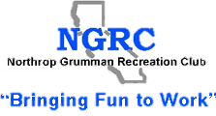
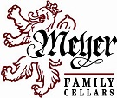 The Space Park Enology Club Presents:
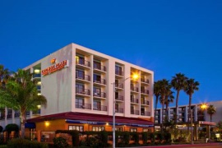 |  | Crowne Plaza Redondo Beach & Marina  300 North Harbor Drive, Redondo Beach CA 90277
 | Reservations required by Friday, January 6th  Reserve online at http://spenology.org/schedule.php  (Follow the link, find “Sign Up,” fill in requested information & click at the bottom of the page)
Reserve online today, and then mail checks to  Mary Ann Hetherington  1605 W. O’Farrell St., San Pedro, CA 90732  Alternate address for internal NGC mail  Enology Club @ S/K09774  Contact Mary Ann with any reservation questions or issues maryannwines@yahoo.com |  |  | The price of this event (parking included) is  $35 for members  $42 for guests (non-members)  Please make checks payable to Enology Club  Must be at least 21 years of age to participate
Guests: If you join the club and pay dues at the event, the $7 non-member cost difference will be applied to your membership fee

Meyer Family Cellars with Matt Meyer

Friday, January 13th, 2017, 7:30 pm
The Space Park Enology Club is pleased to present an intriguing evening of wine tasting with our guest speaker, Matt Meyer of Meyer Family Cellars. In 1972 vintner Justin Meyer and his wife Bonny, co-founded Silver Oak Cellars with partner Ray Duncan and successfully established Silver Oak as one of the finest California Cabernets. http://www.meyerfamilycellars.com

In 1988, Justin and his son Matt found a property in the Yorkville Highlands with the cool climate they wanted for producing a Syrah. Today, the winemaking is a team effort between Matt and his wife Karen. In addition to Syrah and Port, Meyer Family Cellars also makes limited productions of Rose’, Chardonnay and Bonny’s Vineyard Cabernet Sauvignon.

Join us for a Chardonnay Aperitif, followed up with three vertical flights of Syrah, Petite Syrah and Cabernet Sauvignon. An assortment of cheese, fruit and bread will be served. Sign up today to ensure a seat at our tasting.
