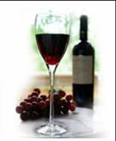

Space Park Enology Club Presents:

Zintilation!
A Traversing of Cal-Zin Regions

Friday, November 4th, 2011, 7:30pm @ the DoubleTree Hotel, El Segundo
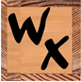
Kyle Meyer, Wine Exchange’s lead wine buyer, will be giving us his impressions as we strike out on our journey of California Zins. In the last 20 years he’s become quite well traveled, domestically and internationally. He’s visited wineries in such diverse locales as France, Italy, Germany, Spain, Austria, Australia and, of course, America. His “Hot Legs” Wine Review video blog has recorded over 100 episodes.
Wine Exchange is an independent, family owned retail wine merchant, founded in 1982 by brothers Steve & Craig Zanotti. They have been at the forefront of discount fine wine sales and were among the first to establish a strong presence on the internet, with their current retail site, www.winex.com.

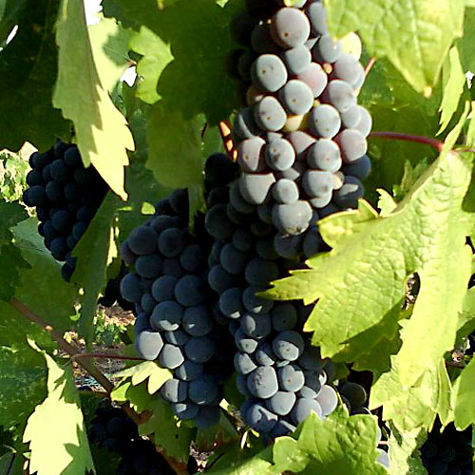
Our senses are sure to be thrilled and challenged as we explore Zinfandels from three of California’s established Zinfandel regions. We will be sampling wines from Napa Valley, the Russian River and Paso Robles. We even have a pair of wines, from different wineries, but with grapes coming from a common vineyard so we may see how the touch & personality of a wine maker can influence how we perceive the wine we experience, when we settle in for a nice glass (or two).
Zinfandel is one of oldest, if not the oldest, grape variety in California and today it occupies about 10 percent of all California vineyards. Zinfandels are typically bold wines that show strong flavors and aromas of berries. The berry flavor and aroma of Zinfandel wine can be so strong that some consider it 'jammy' in character. Other characteristics of Zinfandel grapes include high alcohol content, strong tannins, and slightly spicy flavors.

Please join us on Friday, November 4th at 7:30pm at the DoubleTree Hotel, 1985 E. Grand Ave., El Segundo, CA 90245, between Sepulveda & Continental. An assortment of bread, fruit and cheese will be served.
Reservations by email are required. Deadline for reservations or cancellations is Thursday, Oct 27th!
EMAIL TODAY:  maryannwines@yahoo.com  and then mail checks and reservations to:  NGC Space Park Enology Club  Attn: Mary Ann Hetherington  One Space Park S/1156 (Enology)  Redondo Beach, CA, 90278  (310) 332-4262 | The price of this event is:  $30 for members  $35 for guests  Please make checks payable to:  Enology Club  Must be at least 21 years of age to participate in this event

Zintilation! A Traversing of Cal-Zin Regions: November 4th, 2011
Name Member? Yes No
Name Member? Yes No
Please select confirmation option:
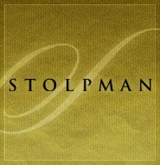
Email Day Phone _

