
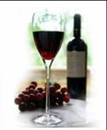
Space Park Enology Club Presents:

Grenache from Around the World
with Wine Specialist Mike Green

Friday, July 15th, 2011, 7:30pm @ the DoubleTree Hotel, El Segundo
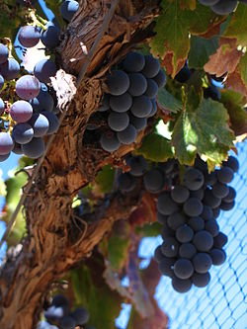
Though known as one of the primary Rhone varietals, Grenache is also one of the world’s most widely planted red wine grapes, producing unique flavor profiles depending on where it is planted. The grape yields soft tannins, well-balanced acidity, and lightly colored yet full wines, endowed with deep notes of strawberry and raspberry.
The long ripening process of Grenache allows the sugars in the grape to reach high levels, making Grenache-based wines capable of substantial alcohol levels, often at least 15%.
Since Grenache ripens late, it needs hot, dry conditions such as those found in Spain (where it is known as Garnacha), Sardinia (where it is known as Canonnau), the Rhone Valley and Languedoc-Roussillon regions of France, California’s San Joaquin Valley and Australia.
Grenache is the dominant varietal in most Southern Rhone wines, especially in Chateauneuf-du-Pape (where it is typically over 80% of the blend), Gigondas and Vacqueyras regions.
Grenache is also the primary varietal in Australia’s popular GSM -Grenache/Syrah/Mourvedre Blends.
The strong wood canopy of Grenache makes the vine difficult to harvest with mechanical harvesters and pruning equipment and more labor intensive to cultivate. Consequently, in highly mechanized wine regions, such as Australia and California, this has contributed to a decline in the vine’s popularity among growers and winemakers.
Mike Green from The Wine House in West L.A. will take us on a spin around the world to experience the many faces of Grenache and Grenache Blends.
Please join us on Friday, July 15th at 7:30pm at the DoubleTree Hotel, 1985 E. Grand Ave., El Segundo, CA 90245, between Sepulveda & Continental. An assortment of bread, fruit and cheese will be served.
Reservations by email are required. Deadline for reservations or cancellations is Thursday, July 7th!

EMAIL RESERVATIONS TODAY TO:  maryannwines@yahoo.com  then mail this reservation flyer & payment to:  Attn: Mary Ann Hetherington  One Space Park S/1156 (Enology)  Redondo Beach, CA, 90278  (310) 332-4262 | The price of this event is:  $30 for members  $35 for guests  Please make checks payable to:  Enology Club  Must be at least 21 years of age to participate in this event

Grenache from Around the World: July 15th, 2011
Name Member? Yes No
Name Member? Yes No
Please select confirmation option:
Email Day Phone _

