

Space Park Enology Club Presents:

Wines from Edna Valley
with Wine Educator Roland Cesarini

Friday, May 20th, 2011, 7:30pm @ the DoubleTree Hotel, El Segundo
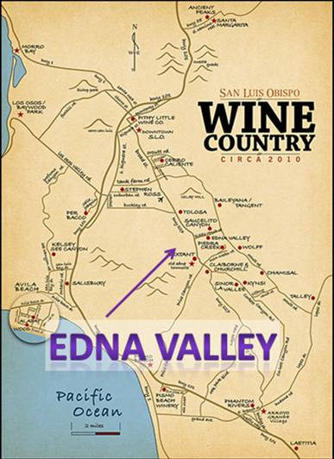
When we think of Edna Valley what we think of first is: “where’s that?” Then someone might say, it’s in the Central Coast area or it’s in wine country.
Edna Valley was approved as an American Viticultural Area (AVA) in May 1982 because of its unique topographical setting and grape growing characteristics. This unique geographical location, cool climate and soil content all have an influence over the grapes grown in the valley and the wines made from those grapes. These traits combine to make this appellation unrivaled in the wine world.
The Edna Valley is a natural, elongated valley encompassing approximately 35 square miles. This transverse valley (running east/west) is well defined by the Santa Lucia Mountains to the northeast, a low, hilly complex to the southeast and by the San Luis Range to the southwest. Unlike appellations in Napa, Sonoma, Paso Robles, and Monterey, there are no major mountains to the west to block the maritime air masses from entering this valley.
A gap exists in the mountain barrier where the Los Osos Valley meets the ocean in Morro Bay. And due to the mild climate, the growing season is typically the longest in California.
In addition to this unique climatic, the soil content is also distinctive. Geographically, the valley soil is a combination of marine deposits and volcanic remnants. The vines grow in areas of marine sediment deposited more than 25 million years ago, consisting of layers of clay, sea shells and beach sand to the soil. Additionally, the soils are enriched by an eroding chain of fourteen ancient volcanoes that begins in Morro Bay and ends at Islay Mountain. Ideal red wines for this region are Pinot Noir and Syrahs as well as many white wines.
Please join us on Friday, May 20th at 7:30pm at the DoubleTree Hotel, 1985 E. Grand Ave., El Segundo, CA 90245, between Sepulveda & Continental. An assortment of bread, fruit and cheese will be served.
Reservations by email are required. Deadline for reservations or cancellations is Friday, May 13th!

EMAIL RESERVATIONS TODAY TO:  maryannwines@yahoo.com  then mail this reservation flyer & payment to:  Attn: Mary Ann Hetherington  One Space Park S/1156 (Enology)  Redondo Beach, CA, 90278  (310) 332-4262 | The price of this event is:  $30 for members  $35 for guests  Please make checks payable to:  Enology Club  Must be at least 21 years of age to participate in this event

Wines from Edna Valley: May 20th, 2011
Name Member? Yes No
Name Member? Yes No
Please select confirmation option:
Email Day Phone _

